Pentecost
The birth of the
world church
Starters for ten: ideas to get you thinking and some things to do to help your church go the extra mile & think outside the box…

1. So, it’s the church’s birthday, but what actually is the church?
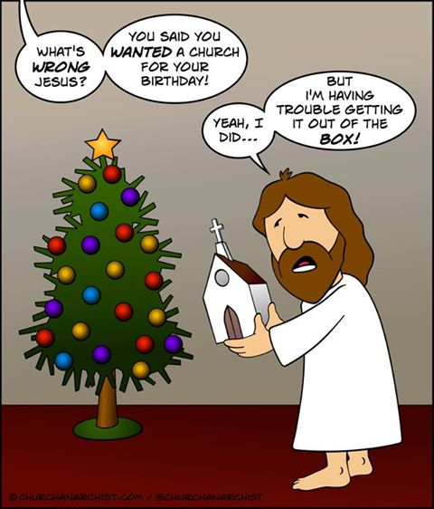
From www.churchanarchist.com, this cartoon illustrates so well how we can find ourselves thinking of ‘church’ as a building; but church is the people of God, filled with the Holy Spirit! The church began as a movement, and only later became an institution with assets and millstones! Can Pentecost be a time to work out how much of the character of a ‘movement’ we can recapture in today’s church, and to take a fresh look at the relationship we have with our church buildings?
2. We believe...
The fact that the Holy Spirit and the Church appear right next to each other in the creed (they’re longer in the Nicene Creed, of course) is both challenging and encouraging. Notice that the Holy Spirit comes before the church – the church can’t be what it should be without the Holy Spirit!
“I believe in
the Holy Spirit,
the Holy Catholic Church….”
(the Apostle’s Creed)

- Brainstorm some words often associated with the Holy Spirit
- Brainstorm some words often associated with the Church
- Are there any words in common?
- Are there any contradictions?

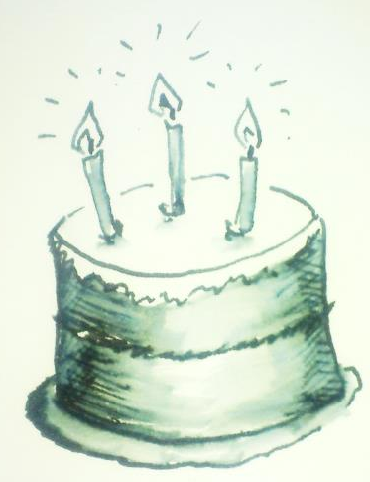
5. It’s a celebration!

Pentecost is often called the Church’s Birthday – so have a party!
What does your church do to celebrate?
- It’s a major festival, so whatever kind of church you are in, go the extra mile: make use of all the liturgical riches that are on offer, let the hymns and songs raise the roof!
- If you usually have coffee and biscuits after the service, how about something little more celebratory? Depending on your context, fizzy wine / grape juice and cake might be just the thing – or something even more fun!
- Make sure people ask themselves: what are we celebrating? Think of your own list of things to celebrate, then Ask others for their ideas, too.

3. Church without walls...

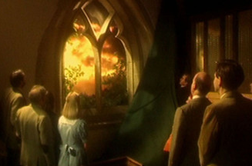
The classic BBC sitcom The Vicar of Dibley included an episode in which one of the church’s stained glass windows was destroyed by a tree blown down in a storm. Funds were raised to replace the window, but the money was given, in the end, to the Colombian earthquake appeal, and a plain glass window installed instead. The ability to see beyond the church walls and out into the world was found to be more important…
Admittedly, sitcom vicars don’t have to worry too much about faculties and so on, but this Pentecost, can you find ways of making the walls of your church thinner, and helping your congregation ‘see out’?
- if you have plain glass windows in your church, what can you see through them?
- if you have stained glass, have a look at what is pictured – can you see evidence of a world church, and of a world beyond the church building?
- Invite people to try their hand at designing the ultimate Pentecost window – would it simply be a gap in the wall? Clear glass? Colourful and bright like flames? Would it feature a world, a galaxy, people? (see the art activity sheet for more ideas).
- Is there any way that you can take all or part of your worship on Pentecost out of the church building? Or give people who come something to do as they leave or once they have left that makes a link between what happens during worship in your church building and what happens after and outside it? (See worship resource sheet for more ideas)

4. God, mission & the church
“It is not the church of God that has a mission in the world, but the God of
mission who has a
church in the world.”

Often quoted, in various versions, and attributed to Jurgen Moltmann, Mission shaped Church, and many others, this is always worth repeating and reflecting on. When did your church last reflect and pray together about what God is already doing and how he is calling you to be art of it?

6. If it’s supposed to be a party, where’s the party bag?
The Holy Spirit is the giver of gifts – could you devise a party bag that reminded people of the message of your Pentecost service? Or perhaps just one gift?
- Miniature bottles of bubble mixture are great fun – you may have used them in worship (see worship resources) so they can be a useful reminder of some of the themes. You can print off labels and stick them on the bottles with a verse from scripture, or a reminder of an action that your congregation is invited to take, or some other relevant message
- A slice of Birthday cake (or a birthday cupcake) can be taken away and given to a friend as an opportunity to share something of the faith.
- Something to take away (especially if it requires further action) helps the service have a more lasting impact than just the hour or so that you are together in church.
- One church gave away little bags with ordinary objects in them to remind them of the Fruits of the Spirit: [Denise to suggest these – add photo]

7. Inside out…
Pentecost celebrates the birth of the worldwide church – the church beyond the building, beyond our own local community, too. How does it feel to be outward-looking? A church home group was once challenged to stand in a circle and hold hands. They did, and then it was pointed out that the natural assumption is to face inwards – they were then asked to try out how it feels to face outwards instead.
We can’t see each other, but we still feel like we’re together.
We can see out – our view doesn’t stop at the other side of the circle.


We have to trust one another more because we’re not looking inwards
We can see if someone’s coming along wanting to join the circle, so we can let them in.

How does your church look outwards?
- Financial support for mission partners overseas
- Intercession for the world
- Supporting and promoting charities
- Involvement with social projects such as foodbanks
- Letter writing and campaigning e.g. for Christian Solidarity Worldwide
- Links with churches overseas or in very different demographic contexts
- Pilgrimages and exchange visits.
If it’s time to revisit how your church looks outwards, could your Pentecost celebrations help to kickstart this process?
8. Share and share alike
Share your ideas for celebrating Pentecost and the world church. You can do this by:
- Emailing [xxxxxxxxxxxxxxxx] – we’ll put the best ideas on the SPCK Pentecost web page
- Tweeting using the hashtag [xxxxxxxxxxxxxxxx]
- (any other ideas)

9. Go in peace to love and serve the Lord…
Have you ever noticed how the structure of Holy Communion is reflected in the whole church year? Advent is a seasons of preparation and gathering in, with Christmas as the sharing of the Word, Easter the sharing of the Sacrament, and Pentecost the sending out at the end. (This also makes the whole period from Trinity Sunday to just before Advent into ‘the rest of life’ – going and living out everything we’ve learned and experienced between Advent and Pentecost!).
It’s well worth putting some thought into how you do the ending of a Pentecost service – how will you send your congregation out into the world not just for a day or a week, but for the whole season until Advent comes round again? (See worship resources for some ideas about ways to end the service…)

10. Go the extra mile…
Being part of the worldwide church isn’t just for Pentecost, it’s for all year round. Here are some great websites that can help you go the extra mile.
- Follow @SPCK_UK #Pentecost on twitter to keep in touch with resources on offer and become a resource for others by sharing your own exciting ideas for celebrating Pentecost and beyond
- www.spck.org.uk/ provides resources for the UK church, and for school collective worship – through www.spck.co.uk/diffusion you can find out about what SPCK is doing to promote the Christian faith in a range of contexts from prisons to football clubs! Through www.spck.co.uk/worldwide you can keep in touch with how SPCK is resourcing the worldwide church through provision of educational materials for people training for ministry in Africa, Asia and Latin America, and assisting with translation projects in India. You can also find out how you and your church can support this work both prayerfully and financially.
- Christian Solidarity Worldwide (www.csw.org.uk) supports Christians who are persecuted for their faith, researching individual cases so that churches here can provide prayerful support, write letters of encouragement, and lobby for justice and mercy for those in prison and in danger. They also provide advocacy and undertake campaigning.
- The Women’s World Day of Prayer (www.wwdp.org.uk) in the UK takes place in early March each year, with worship planned by a different nation each year – services are open to both men and women and provide a fascinating insight into the concerns and wisdom of Christians of other nations throughout the world.

