Pentecost
The birth of the
world church
Resources for worship
Worship comes in all shapes and sizes – and nobody knows your own context better than you do – but Pentecost can be a chance to do something different, think outside the box, and draw on traditions that may be unfamiliar but are full of riches to help your church feel part of the world church.

The outline for a Service of the Word is offered for you to use as it stands or to adapt to your own circumstances – or you may wish to use just parts of it to supplement your regular liturgical pattern.

Resources for preaching and teaching are also provided separately.

In this document there are suggested alternatives for various parts of the service, and additional resources for alternative, all age and Eucharistic worship.

Where this material has come from
This material includes texts from various sources; each item is followed by a note indicating where it may be found.

Extra note for Church of England parish churches
There are rules within the Church of England about what liturgical texts may be used; certain elements of an act of worship require an ‘authorised’ text, while others can draw from a wider range of sources and traditions, or can be specially written. If you’re not sure what is allowable, there are good, clear explanations in the introductory section of New Patterns for Worship, and in the Common Worship main volume (black book) in the introduction to A Service of the Word.

Alternative suggestions
These suggestions are for churches which will have difficulty with any of the items in the complete service sheet, perhaps because of limited musical resources. Or, they can be used simply to provide some additional material.
Alternative Songs and hymns

Opening songs:
Here in this place / Gather us in
Be still, for the presence of the Lord
Come down, O Love divine
Songs after the presentation:
All over the world the Spirit is moving Roy Turner
He’s got the whole world in his hands traditional

Songs for the offertory:
Longing for light / Christ be our Light (B Farrell)
Song for the lighting of candles:
Share the light of Jesus, Bernadette Farrell
Lord, the light of your love is shining Graham Kendrick
This little light of mine traditional
Final songs
Go forth and tell
Colours of day
Hope of our calling

Other songs, hymns and chants you may wish to try:
All over the world
Be still, for the presence of the Lord
Come down, O Love divine
Come, Holy Spirit John Bell
Come, living God, when least expected Alan Gaunt
Come, O Holy Spirit, come Nigerian traditional
He’s got the whole world in his hands traditional
Let all the world in every corner sing George Herbert
Lord, draw near John Bell
O breath of life come sweeping through us
O thou who camest from above
Spirit of God, unseen as the wind
Spirit of the living God Iverson
The Spirit lives to set us free
This is the day traditional
Veni Sancte Spiritus - Come, Holy Spirit Taize

Invocation of the Holy Spirit
Wind of God, blow far from us
all dark despair,
all deep distress,
all groundless fears,
all sinful desires,
all Satan’s snares,
all false values,
all selfish wishes,
all wasteful worries.
Blow into us
your holy presence,
your living love,
your healing touch,
your splendid courage,
your mighty strength,
your perfect peace,
your caring concern,
your divine grace,
your boundless joy.
Wind of God,
blow strong,
flow fresh,
blow now.
Pamela Wilding, Kena
From Prayers encircling the world.
Collects / Opening Prayers
Gather or scatter us, O Lord, according to your will.
Build us into one Church:
A Church with open doors and large windows,
A Church which takes the world seriously,
ready to work and to suffer, and even to bleed for it.
(from the Church in Hungary)

O Lord our God, listening to us here,
you accept also the prayers of our sisters and brothers
in Africa, Asia, the Pacific, the Americas and Europe.
We are all one in prayer.
So may we, as one, rightly carry out your commission
to witness and to love in the church
and throughout the world.
(from the Church in Ghana)
published in A Wee Worship Book © 1999 Wild Goose Resource Group

Invocation of the Holy Spirit
Wind of God, blow far from us
all dark despair,
all deep distress,
all groundless fears,
all sinful desires,
all Satan’s snares,
all false values,
all selfish wishes,
all wasteful worries.
Blow into us
your holy presence,
your living love,
your healing touch,
your splendid courage,
your mighty strength,
your perfect concern,
your divine grace,
your boundless joy.
Wind of God,
blow strong,
blow fresh,
blow now.
Pamela Wilding, Kenya
(from Prayers Encircling the world)

Invocation of the Holy Spirit
We pray to God to fill us with his Spirit, saying,
Lord come to bless us,
And fill us with your Spirit.
As we listen to your word,
Lord come to bless us,
And fill us with your Spirit.
As we worship you in majesty,
Lord come to bless us,
And fill us with your Spirit.
As we long for your refreshing,
Lord come to bless us,
And fill us with your Spirit.
As we long for your renewing,
Lord come to bless us,
And fill us with your Spirit.
As we long for your equipping,
Lord come to bless us,
And fill us with your Spirit.
As we long for your empowering,
Lord come to bless us,
And fill us with your Spirit.

Common Worship, Times and Seasons

Pentecost, a sonnet by Malcolm Guite

Today we feel the wind beneath our wings,
Today the hidden fountain flows and plays,
Today the church draws breath at last and sings,
As every flame becomes a tongue of praise.
This is the feast of Fire, Air and Water,
Poured out and breathed and kindled into Earth.
The Earth herself awakens to her maker,
Translated out of death and into birth.
The right words come today in their right order
And every word spells freedom and release.
Today the gospel crosses every border,
All tongues are loosened by the Prince of Peace.
Today the lost are found in his translation,
Whose mother-tongue is love, in every nation.

Malcolm Guite, Sounding the Seasons
(Canterbury Press, 2012)

An alternative prayer for the blessing of light
O God our heavenly Father,
as we light this candle
and watch the flame grow,
kindle within us afresh
the flame of your Holy Spirit.
Let us so glow with your love
that others may see you in us
and want to know you;
in our homes, our Church,
our parish, our diocese.
Bless those who light candles each day as a token of witness
to the light of your power and glory;
and to the coming
of your kingdom on earth.
This we ask in the name of Jesus.

Women of St Asaph diocese, Wales
from Prayers encircling the world

An alternative prayer for the Commission / sending out

Holy Spirit of God,
you came on the Day of Pentecost,
to change the lives of the disciples,
who had hidden themselves in the Upper Room
for fear of the Jews.
Come amongst us, we pray you,
to transform our lives.
Make Jesus real to us,
reassuring us and strengthening our faith in him.
Set us apart for the service of Jesus,
not taking us out of the world,
but sending us into it,
to proclaim boldly the good news of his saving love.
Spirit of Life, come into our lives
and make them alive with the Life of Jesus,
our Living Saviour.
For his name's sake.

William N Richards and James Richardson, Kenya
from Prayers encircling the world

An alternative prayer for the Commission / sending out
(or for after the absolution)
Eternal father,
you sent your Son
to bring the Good News
of your forgiving love to us sinners.
Your Son in turn sent the Holy Spirit
to continue his mission on earth
through the Church.
Quicken us, we pray,
by the same Spirit
that we shall not rest
until all people are reached with your Gospel, through Jesus Christ our Lord.
NaJtali Okello Siwa, Kenya

‘Extras’ for multisensory,
all-age & alternative worship

At the start of the service

If you want to be a bit more interactive:
After the opening greeting, ask people where they have come from in order to be in church today, or where they originally came from – celebrate the diversity of your congregation and link it to the crowds of pilgrims gathered in Jerusalem for the festival of Pentecost when the gift of the Holy Spirit was poured out on the disciples.
If you want to be a bit more creative:
You could create a picture as people arrive, asking them to add a self-portrait (probably just a stick figure with a name by it, for most people!) to a big piece of paper to celebrate the in-gathering of all those who have come. If people aren’t confident about drawing, you could provide simple ‘person shapes’ (of a variety of body shapes and on a variety of paper colours) on which people could write their name and then stick them onto one single piece of card. You could even arrange the people to form the shape of a church, a dove, a flame….
If you want to be a bit more active:
games for the children involving collecting items from around the church to bring together can be effective – you could cut out the continents from a large world map and hide them around the church for the children to find and then put together as a focal point which can then be used in the prayers. A children’s world map jigsaw could also be used. These activities would also work well during the powerpoint presentation, if you use it.
If you want to give space for more personal prayer:
Common Worship: Times and Seasons also provides a liturgy for anointing with oil in the context of prayer for personal renewal (Times and Seasons, p.493)

During the songs
Children may like to dance or wave streamers (red, yellow and orange ribbons tied to a ring or stick) during the songs. These can be made in advance or during the presentation near the start of the service. This can be a great way for children who don’t read yet to praise God through music and song.

During the presentation, sermon etc
Have a look at the ‘preaching and teaching’ document for a wealth of ideas that can help to engage children in the themes of Pentecost and the World Church – many of them can be done as part of or alongside the liturgy.

A more all-age friendly Affirmation of Faith
God’s Spirit is building us into God’s people.
Let’s declare together the things we believe.
Sandra Millar, Festivals Together, SPCK 2012, p.65
We believe in God the Father,
from whom every family
in heaven and on earth is named.
We believe in God the Son,
who lives in our hearts through faith,
and fills us with his love.
We believe in God the Holy Spirit,
who strengthens us
with power from on high.
We believe in one God;
Father, Son and Holy Spirit. Amen.
New Patterns for worship, E12

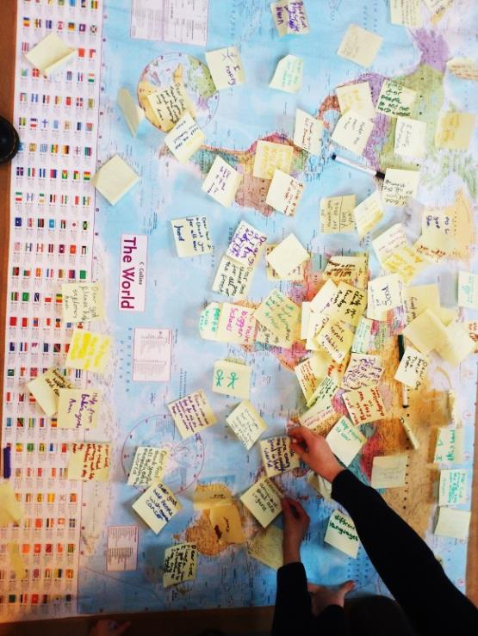
All-age friendly and multisensory prayers
For some hands-on prayers, you could ask the congregation to write prayers on post-it notes, particularly remembering the worldwide church; these prayers can then be stuck to a world map.

Tea-lights could also be lit and placed on a world map laid on the floor, particularly focusing on those countries with which the church has a special connection or countries where Christians are in danger.

If the children will need to do something quiet during ‘adult’ prayers, print out some pictures (from a google image search!) to represent different intercessions, particularly focusing on what the spoken prayers will include. If you have particular charities that you support as a church, include their logos. If you have mission partners in particular countries, include photos of them, and those countries’ flags. Lay all the picture on the floor - children can listen to the prayers and pick out images which reflect what’s being said.

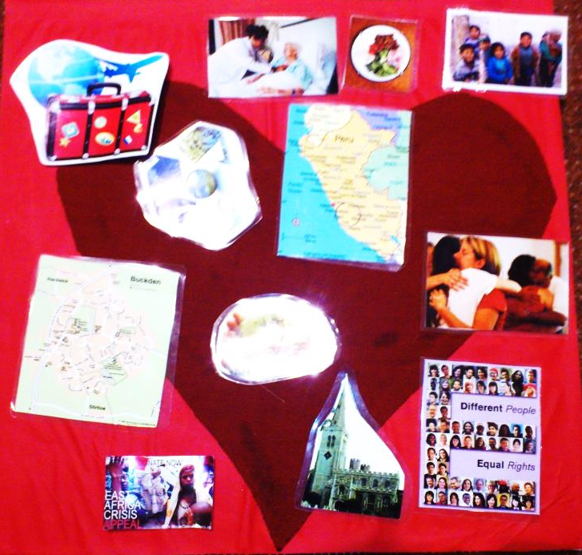

Going outside?
The order of service suggests going outside during the last hymn so that the dismissal takes place outdoors. There are lots of variations on this idea! Here are some that have been tried and tested:
One church decided they would all go outside for the final part of the service, and got some giant bubble blowers so that they could release bubbles into the air to float away from the church – the all-age talk had used bubbles. They had thought about using helium balloons or Chinese lanterns but decided against it because of the environmental issues these raise.
Another church decided they would also start outside the church building. They gathered outside the door, and read the reading from Acts 2, then came into church during the first song.
Another church had their whole service outside, jointly with other denominations, in the context of a bring-and-share picnic. A large plain iced cake was provided, and when people arrived they wrote their initials on the cake with writing icing, and the cake was then cut during the service (while Happy Birthday was sung, to the church) and distributed – people could eat their own slice of cake or take it round to a friend as an opportunity for sharing what had happened at the service.
Another church had a more elderly congregation, and didn’t feel they could go outside, so at the end of the service, they all turned towards the door of the church, which was opened for the dismissal, as a reminder to take the love of God out into the world.

‘Extras’ for Holy Communion

Texts from the Anglican Church in Kenya
The liturgy of the Anglican Church in Kenya is not authorised for use in the Church of England, so for those parts of the Holy Communion service which require an authorised text, you may wish to consider the options in Times and Seasons and in New Patterns for Worship.
Other parts of the Kenyan liturgy can, however, be used within celebrations of the Eucharist in the Church of England, and some of these are given below (in addition to those already given as part of the outline ‘Service of the Word’ above), as a way of celebrating the place of our local churches within the whole worldwide family of God’s church on earth.
The Gloria This version may be accompanied by regular clapping. The words in square brackets, may be altered to reflect the local context.
Glory to the Father,
Glory to the Son,
Glory to the Spirit,
For ever Three in One.
Be glorified at home,
Be glorified in church,
Be glorified in [Kenya],
Be glorified in [Africa],
Be glorified on earth,
Be glorified in heaven.
Glory to the Father,
Glory to the Son,
Glory to the Spirit,
For ever Three in One.
Alleluia, Amen.

A Prayer of Preparation
Almighty God,
you bring to light things hidden in darkness,
and know the shadows of our hearts:
cleanse and renew us by your Spirit,
that we may walk in the light
and glorify your name. Amen

A prayer after the absolution or before receiving communion
Thank you, Father, for forgiveness.
We come to your table as your children,
not presuming but assured,
not trusting ourselves but your Word.
We hunger and thirst for righteousness,
And ask for our hearts to be satisfied
with the body and blood of your Son,
Jesus Christ the righteous. Amen

Eucharistic Preface
This Extended Preface, adapted from the Kenyan service of Holy Communion may be used with Eucharistic Prayers A, B, or E:
It is right and our delight to give you thanks and praise,
great Father, living God, supreme over the world,
Creator, Provider, Saviour and Giver.
From a wandering nomad you created your family;
for a burdened people you raised up a leader;
for a confused nation you chose a king;
for a rebellious crowd you sent your prophets.
In these last days you have sent us your Son, your perfect image,
bringing your kingdom, revealing your will,
dying, rising, reigning, remaking your people for yourself.
through him you have poured out your Holy Spirit,
filling us with light and life.
Therefore with angels and archangels,
faithful ancestors and all in heaven,
we proclaim your great and glorious name,
for ever praising you, and saying:
For guidance on how to include an extended preface, please consult the instructions in the Common worship main volume, page 333, or the red rubrics for each Eucharistic prayer.

After the distribution of communion
O God of our ancestors, God of our people,
before whose face the human generations pass away;
We thank you that in you we are kept safe for ever,
and that the broken fragments of our history
are gathered up in the redeeming act of your dear Son,
remembered in this holy sacrament of bread and wine.
Help us to walk daily in the Communion of Saints,
declaring our faith in the forgiveness of sins
and the resurrection of the body.
Now send us out in the power of your Holy Spirit
to live and work for your praise and glory. Amen.
Before the distribution
of communion
Christ is alive for ever:
We are because he is.
We are one body:
We share one bread.
We break this bread:
To remember his death.
We share this cup:
To receive his life.
Draw near with faith:
Christ is the host
and we are his guests.

Other useful texts

NB For Services of Holy Communion, the lectionary gospel is
John 20.19-23 or John 7.37-39

The Kyrie
has simple congregations from many traditions, include Taizé and Iona

The Peruvian Gloria
is now well known, and printed in several mainstream hymn books

Short preface
suitable for use with additional Eucharistic Prayer Two
(specially written, so not from a world church tradition)
You send your Spirit as our breath of life,
to fill our words and actions
with your amazing love,
and to make us a blessing
for all the world.

