Preparing for Holy Communion
“The Lord be with you”

Jesus talks a lot about belonging.

We can belong in lots of different ways, and with different people.
Write down some of the groups that you belong to:

How do we know if we belong to a group, or a family, or a club?
How do other people know that we belong?

How do we belong to God? How do we belong to the church?

Jesus’ flock of sheep – John 10.14-16

Jesus ‘I am the good shepherd. I know my own sheep and they know me, just as the Father knows me and I know the Father. And I give my life for the sheep. I have other sheep that aren’t from this fold. I must bring them too, and they will listen to my voice. So there will be one flock, and one shepherd.

Which picture do you think is most like the church? Why?
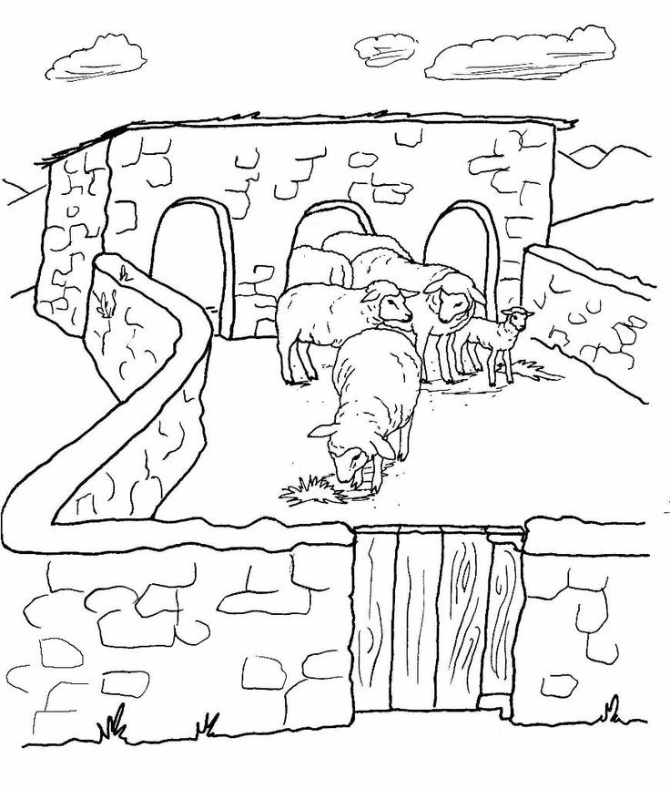
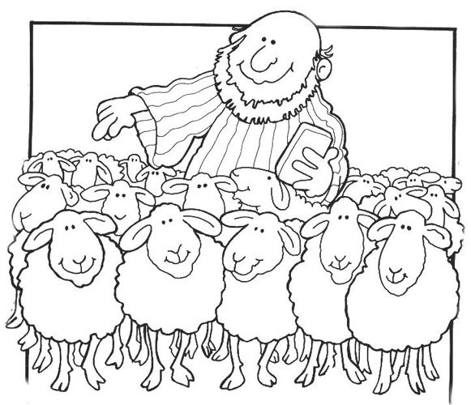
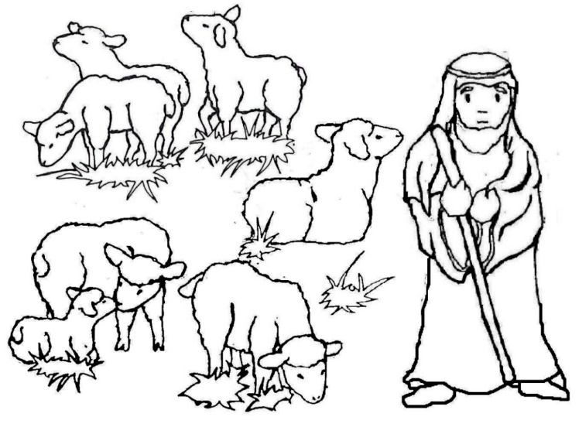

Draw your own picture of
the church here:

The Body of Christ – 1 Corinthians 12.12-31

Paul Just as a body is made up of different bits, but it’s still one body. It’s the same with Jesus. We were all baptized by one Spirit to make up one body. So if the foot says,
Foot: “I am not a hand, so I don’t belong to the body,”
Paul it wouldn’t stop being part of the body.
And if the ear says,
Ear “I am not an eye, so I don’t belong to the body,”
Paul it wouldn’t stop being part of the body.
A body can’t be made just out of eyes – how would it hear?
And if it was all made of ears, how would it smell or taste anything?
God has put the parts in the body, every one of them, just as he wanted them to be. There are many parts, but one body.
That’s why the eye can’t say to the hand,
Eye “I don’t need you!”
Paul And the head can’t say to the feet,
Head “I don’t need you!”
Paul Actually, every part of the body matters. If one part hurts, every part hurts with it; if one part is honoured, every part is happy. Now you are the body of Christ, and each one of you is a part of it.
How is the Church like a body?
Are some jobs are more important in church than others?
Do you have a special job? Would you like to have one?

Try these at home / church:
MAKE a poster to show what it means to belong to Jesus and to his church.

THINK of someone who belongs to the same group as you. Think of five things you have in common with that person, and five things that are different.


PRAY for people who belong to the same groups as you.

Tip: you don’t have to do these on your own – you can do them as a family
DOODLE
on the service booklet you have been given – look for interesting words, match it with the actions, draw some doodles to help you wonder about it all.

REFLECT on why you want to receive Holy Communion. It’s good to know in your own mind and heart why this is important to you, even though it’s hard to put that into words.

Next time:
“We Confess”
Our relationship with God
and with one another.

