Praying Together
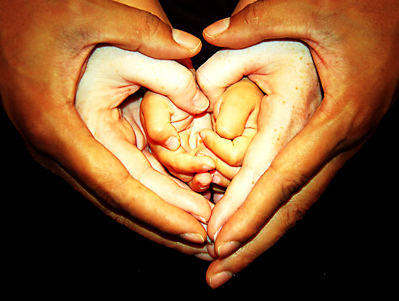
for families and children

About this book
Prayers come in all shapes and sizes:
- Some prayers use words
- Some prayers use actions
- Some are thoughts or feelings that we share with God but can’t express
We can pray when we are happy, or excited, or when we want to say ‘thank you’ for something.
We can pray when we are sad, or afraid, or lonely, or when we need some help.
We can pray just to say ‘hello’ to God. Talking to God and listening to God – just spending time with God - helps us to get to know God better.
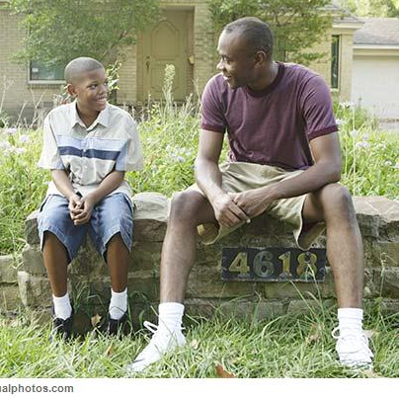
This book isn’t a collection of prayers. If you’re looking for one, there are some good ones recommended on page xx
This book is rather an approach to praying that honours children’s spiritual life, their desire to know God, and their ability to share wisdom with those of us who may have forgotten what awe and wonder are like.
Getting ready to pray
You can prayer anywhere, anytime. But if you know there’s something special you want to pray about, or if you want to set aside some time to pray, it might help to:
- Find a place where you feel safe and you won’t be disturbed;
- Light a candle, or hold a cross in your hand, close your eyes or hold out your hands;
- Sing a song, such as
This is the way we pray to God,
pray to God, pray to God,
this is the way we pray to God,
we know that God will hear us.
(To the tune of The Mulberry Bush)
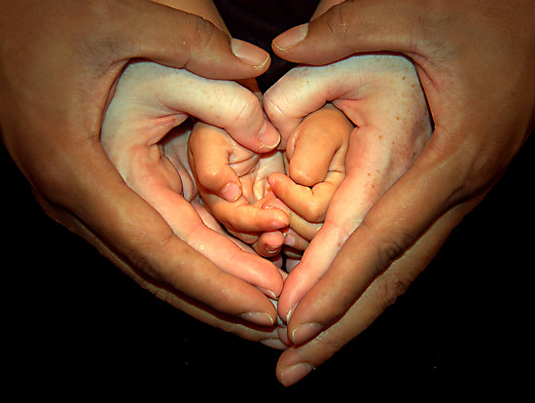
Being with God

Sometimes it’s just good to be with God. We can’t see God, but God is everywhere, and is closer to us than we are to ourselves.
You can say a line at a time for your child to repeat, as you both do the actions.

God be with me, clasp hands
God within me, both hands on heart
God behind me, look over shoulder
God before me, look ahead, shielding eyes
God beside me, look to the side
God to win me, hands clasped held high
God to comfort me and love me. share a hug

God beneath me, look down
God above me, look up
God in quiet, whisper, finger on lips
God in danger, hands over eyes
God in friends look at each other
God in family, hand on heart
God who cares for me for ever. share another hug
Praying in the morning
Thank you, God,
for keeping us safe in the night.
Bless us in everything we do today,
and help us to be a blessing to everyone we meet.

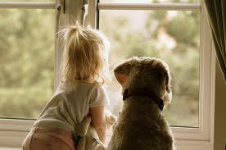
Song:
Thank you God for this new day,
Thank you God for this new day,
Thank you God for this new day,
Right where we are.
Thank you God for …
Add your own ideas – include some of the things you are looking forward to about the day that’s just started.
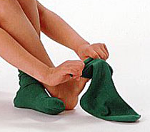
As we put on our clothes,
help us also to put on
goodness, truth, kindness,
patience and love,
and wear them all day.

Praying about food
Find out where your food comes from – try and trace a whole meal back from the plate all the way to the people who grew the ingredients. Say a thank you prayer for everyone involved. You could make a thank you card for the people who work in your local shop.
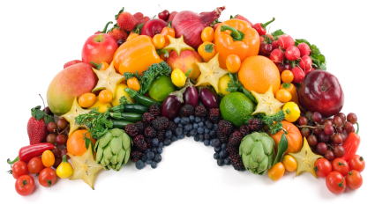
Try ‘saying grace’ before every meal, or before some special meals. Saying grace means saying thank you to God for everything he has given us, and especially for our food.
Here are some graces to try, or you can make up your own.
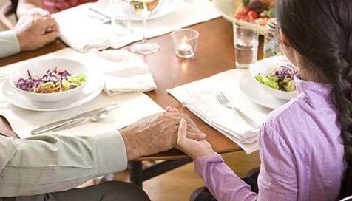
One, two, three, four, five,
Thank you God that I’m alive.
Six, seven, eight, nine, ten,
Thank you for our food. Amen!
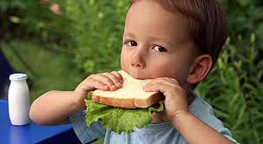
Thank you for food and for family and friends who share it with us.
Help us to find ways of helping those who have neither.
Rub a dub dub,
thanks for the grub!
Praying for other people

Write a prayer list – be creative! You could write the name of people and situations on a paper ‘people chain’, on pebbles, on strips of paper that you make into paper chains…
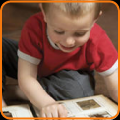
Start a prayer album, using photographs of people you want to pray for. This is a lovely way to remember friends or relatives that you don’t see very often.

If you watch the news together, light a candle for each of the news stories. Talk about what is ‘dark’ in those places, and who is bringing light to them.


Get a map out of your local area, or of the world, and trace your fingers along the streets, or round the countries. Think about God’s love for the people in those places. Ask him to bless them all.
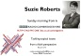


Make a prayer board – cut out pictures from newspapers and magazines that inspire you to pray, and pin them to the board as you pray for them. You can get beautiful pin boards – even heart shaped!
Actions and ‘things’

Feather - find a fluffy feather, and play with it. Stroke it on the back of your hand to feel how soft it is. Very gently blow on it. We can’t see our breath, but we can see how it moves the feather. There are many things that we can’t see, but we know they are real.


Bubbles – blow some bubbles together. If you blow slowly, you will get a big bubble, if you blow quickly you will get lots of little ones. Imagine you are blowing all your prayers straight out of your soul. They float away, and when the bubbles pop, God has collected your prayers.
Cushion – find a soft, squashy cushion (you can buy heart-shaped cushions around St Valentine’s Day). Hug the cushion as you think about the people you love. Think about how much you want God to bless them. You can also think about people who are ill, or sad, or lonely.
Actions and ‘things’
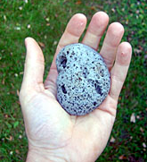
Stones – find some interesting stones (you could collect some on holiday, or from a gravel driveway). Choose one, and hold it in your hand. Is it rough or smooth? Is it rounded or has it been broken? All stones change their shape over time. We are a bit like that. Sometimes we think we might have been broken by a bad thing that’s happened, but perhaps we have just changed shape. We can become smoother by life rubbing off the sharp corners. Feel the stone become warm in your hand. Imagine the warmth of God’s love surrounding you and the people close to you.
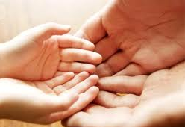
Hands –Make the ‘thumbs up’ sign and say thank you to God for something good. Point with your index finger, and ask God to guide you in the future. Wiggle your middle, strongest finger, and ask God to bless the strong people of the world: leaders, teachers, people in authority. Link your ring fingers together, and think about the people you love. Wiggle your little fingers and think about the weaker people in the world: the poor, the sick, refugees, people in prison...
Actions and ‘things’
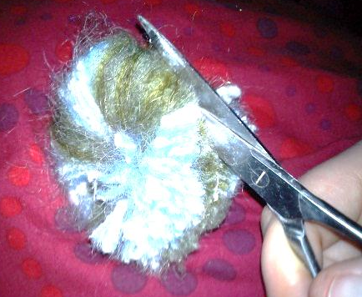
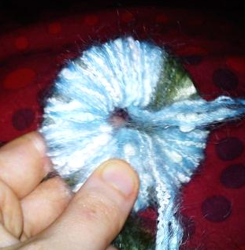
Pom Pom – cut out two card discs with hollow middles (the size and shape of pineapple rings). Put them together, and wrap green and blue wool around them until you run out of room through the middle hole. Cut round the edge, slide a length of wool between the discs, and tie it tight. Tear the discs to remove them, and fluff out your pom pom!
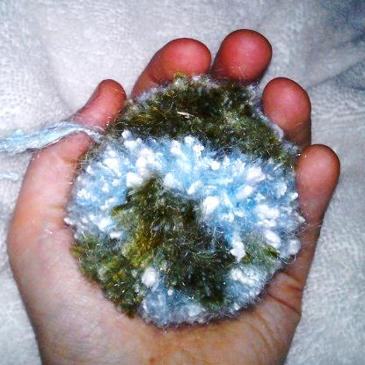
Give your child the pom pom to hold. Talk about how it looks a bit like the world. Talk about how it was hard to make, and took a long time. Talk about how you want to keep it safe now you’ve made it. Talk about what it felt like to cut round the edge! Imagine that their hands are God’s hands, and that the pom pom really is the world. Sing ‘He’s got the whole world in his hands’. Think about all the precious things in the world that God loves.
‘I saw in my hand a ball the size of a hazel nut, and somehow I knew that it was everything in the universe. I wondered how it could last; it was so small it might just disappear. And somehow I knew that it lasts, and will last for ever, because God loves it.’ (based on Julian of Norwich)
Actions and ‘things’
Blanket – get hold of a really soft blanket and take it in turns to pray for one another by wrapping the blanket around each other. [image] – I need to expand this, and add another couple of examples.
Beachcombing – this doesn’t have to take place at the seaside! It’s simply a way of looking at the world that finds things interesting – the world is full of delightful and intriguing things, and we often pass them by without taking the time to ‘stop and stare’. Sometimes we can pick up and take home some of the things we see, and keep then in our special place at home (see p.x).

Go for a walk
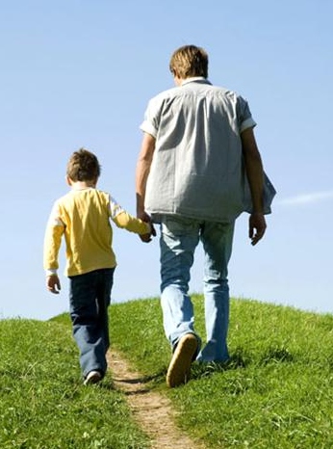
Look up at the sky: What colours can you see? Are there shapes in the clouds?

Look at the ground under your feet: Are you walking on tarmac, on grass, or on something else? if it’s been raining, are there puddles to splash in? What can you see reflected in them?
Look to either side of you: are there houses? Do you know who lives there? Are there trees and plants? Look at the colours, the shapes. How can you tell if it’s spring, summer, autumn, or winter?

Look at the night sky. See if you can recognise any constellations. Think: light from even the nearest star to earth is so far away that it takes hundreds of years to reach us. God’s universe is a big, big place! Let yourself feel awe.
Make a special place
Find somewhere in your house that can become a ‘special place’ – a bookshelf, alcove, or similar is ideal.
This is where you might like to put your Bible, prayer book, a cross, your prayer cushion, your prayer list, and any ‘special things’ you find on your walks that remind you of God in the world.
It is somewhere that you can go to pray, or to spend some time quietly.

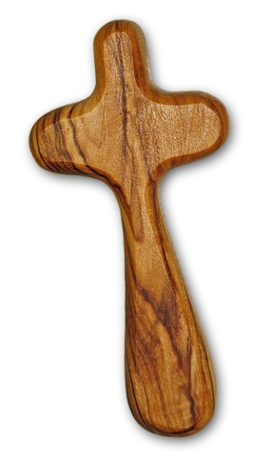

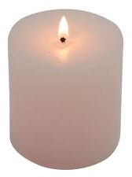

Praying with the Bible

God makes the universe
The Bible tells of God creating the whole universe from scratch, bringing light out of darkness, order out of chaos, and filling the sea, the air and the land with life. Last of all it tells how human beings were made to care for the world, and to enjoy being friends with God.
Science also tells us that there is order and mystery in the world, that there are many things we don’t understand, and that we are responsible for the care of this planet.
Make a ‘world pop pom’ (see page xx) and pray with it.
Look at a world map or encyclopaedia and talk about the sorts of animals and plants there live in other parts of the world. Talk about endangered species, pollution, litter…
Collect some natural objects (such as leaves, stones, sticks, miini-beasts etc) and look at them with a magnifying glass. Say thank you to God for how awesome life is.
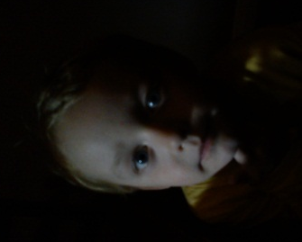
Go somewhere dark (even a large cupboard) and switch on a torch. Say thank you to God for the gift of light.
Praying with the Bible
The flood and the rainbow
When the world had got into such a mess that it needed a new start, God chose Noah and his family to make sure that the animals in the ark survived to fill the world with life again.
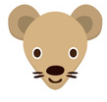
Use an animal matching card game to make a treasure hunt. Talk about making sure every single one is found and kept safe.

If you were making an animal or a plant from scratch, what would it be like? Where would it live? What colours would it be? Draw your invented life-forms!
If you see a rainbow, talk about how it makes you feel. Noah saw the rainbow as a sign that the rain had ended and that the sunshine had arrived. Think together about all the signs that God is in the world, and cares for the world.

Find out about places in the world where there are natural disasters. Find a relief charity, such as Christian Aid, or the Red Cross, and make a donation.
You could also start supporting a charity that cares for the environment.
Praying with the Bible
Daniel and the lions
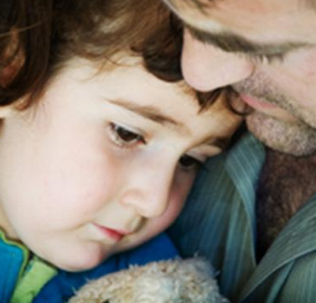
Daniel was a brave friend of God. He prayed to God even though the king had forbidden it, and for this he was thrown into a den of lions. But God was with him, and sent his angels to close the lions’ mouths. Then the king realised that Daniel’s God was the real God.
Talk about times when you have been afraid. What do you do to be brave?

Say thank you to God that you are allowed to pray. Think together about how you pray – when and where.

How do people around you see that you are a friend of God? How do you remind yourself that you are a friend of God? Some people carry a cross in their pocket, or wear one.

Praying with the Bible
Jesus and the little children
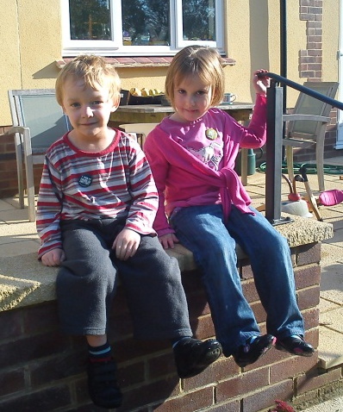
People kept bringing their children to Jesus, wanting him to bless them. Jesus’ friends tried to send them away. But Jesus said, ‘Let the little children come to me, and don’t ever stop them, because heaven belongs to them.’
Parents: tell your child what you want most for them – the blessings that you pray God will give them in their life. Children: what blessings would you like God to give to your family, your friends, and to all the people you love?
We hope for…………………………………………………………………..
………………………………………………………………………………………
We thank God for…………………………………………………………..
………………………………………………………………………………………
Remember, Jesus said that heaven belongs to people who approach God as children do. Parents: take this chance to ask your child what they think God is like, and how they feel about praying, going to church…. Share a hug together.

Praying with the Bible
The storm and the cushion
One day, Jesus and his friends went out in their boat on the lake. Jesus was tired, and went to sleep on a cushion.
While he was sleeping, there was a storm. His friends were terrified. They woke him up, and he stood up in the boat and said ‘Peace, be still,’ to the wind and the waves, and the lake was calm again.
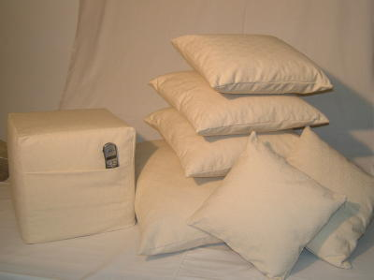
If you’ve chosen a prayer cushion already, hug it tightly as you pray. Think together about all the ‘stormy’ things of life: not just scary weather, but other things that make us feel afraid, or sad, or worried. Remember Jesus asleep on the cushion even in the storm. Let the softness of the cushion remind you about what helps you feel safe, and that God’s love for you is stronger than everything.
Bedtime Prayers
These bedtime prayers are based on the ancient church service called ‘Compline’ or ‘Night Prayer’, which asks God for protection during the dark hours of the night. You can use all these prayers each bedtime, or just choose some of them.
God give us a quiet and peaceful night.
You made the world and everything in it.
We put our trust in you.
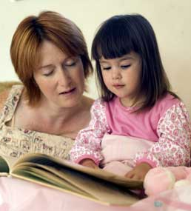
Talk together about the past day.
What has been good?
What has been not so good?
Is there anything you did that you wish you hadn’t done?
Or anything that you should have done, and didn’t do?

Dear God,
We are sorry for the wrong things we have thought.
We are sorry for the wrong things we have said.
We are sorry for the wrong things we have done.
We are sorry about the good things that we didn’t do.
Forgive us for what is wrong,
and help us to live lives that show your love. Amen.
Bible reading
Share one of the bible stories earlier in this book, or another story from a children’s bible.
Hold your hands out in front of you.
Dear God, we know we are safe in your hands.
We place into your loving hands all those we love.

Song
He’s got the whole world in his hands,
he’s got the whole wide world in his hands,
he’s got the whole world in his hands,
he’s got the whole world in his hands.
He’s got [name of child] in his hands…
He’s got [other family members] in his hands…
He’s got [friends, teachers, etc] in his hands…
He’s got [others in trouble -in the wider world] in his hands…
He’s got [people you know who are ill] in his hands…
He’s got [people you know who have died] in his hands…
He’s got the whole world in his hands…
Keep us as the apple of your eye. (smile at one another)
Hide us under the shadow of your wings. (share a hug)
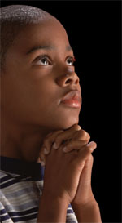
Keep us safe in the daytime,
when we are awake,
Keep us safe in the night time,
when we are asleep.
You are always with us,
and will never leave us.
The light of your love
is the light for all the world.
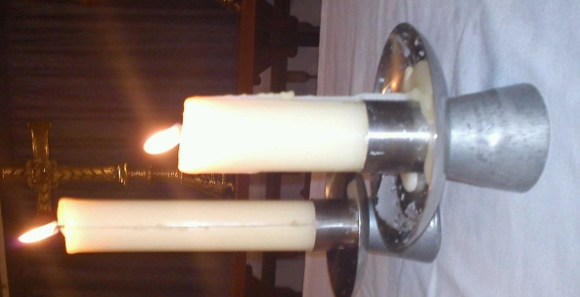
Be with us in the silence of the night.
When the day has made us tired,
When the dark makes us afraid,
Give us peace in knowing
that you are always here, always loving.
Watch over those who lie awake tonight,
and may your angels watch over those who sleep.
Bless those who are sick,
Give rest to those who are tired,
Comfort those who are worried or sad.

The Lord’s Prayer
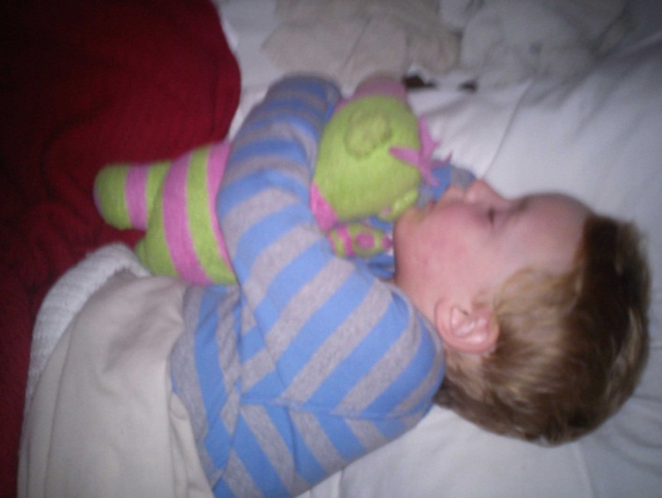
Our Father in heaven, hallowed be your name.
Your kingdom come,
your will be done on earth as it is in heaven.
Give us this day our daily bread.
Forgive us our sins as we forgive those who sin against us.
Lead us not into temptation, but deliver us from evil.
For the kingdom, the power and the glory are yours,
now and for ever. Amen.
Song
Say goodnight, say goodnight,
Sleep in peace, sleep in peace,
All my love surrounds you,
all my love surrounds you,
God bless you, God bless you.
(tune: Frere Jacques)

Resources

Bibles – reading the Bible is an important part of being a Christian, so it’s well worth finding a version you can understand. Some of the best children’s bibles include:
- Baby’s Hug-a-Bible, published by Harper Festival, 2010
- The Lion First Bible, published by Lion Hudson, 2008)
- The Usborne Children’s Bible, published by Usborne, 2009)
Prayer Books – these can be helpful if you want some help putting your thoughts into words when you pray. Some children’s prayer books include:
- My very first prayers, published by Lion Husdon, 2003
- Baby Prayer, published by Lion Hudson, 2007
- The Lion Book of Prayers for Children, published by Lion, 2009
There are lots of useful websites that can help families grow in faith, including:
- www.spiritualchild.co.uk
- www.faithinhomes.org.uk
- www.themothersunion.org/flourishing_relationship.aspx
- www.faithlink.com/Inkubators/faith5.asp

