Enriching Children’s Experience of Eucharistic Worship in Church
What can we do differently?
If you can get your PCC and congregation behind some bigger changes, then the possibilities are limitless.
The New Eucharistic Prayers offer more accessible but still liturgically gracious language, a shorter overall length with shorter lines, and options for greater participation. It is possible to benefit from many aspects of the new prayers while retaining a format that congregations find familiar: the repeated ‘Holy’ in Prayer One is optional, as are the questions in Prayer Two – this means that switching to these new Prayers for all age Eucharistic services needn’t be a huge culture shock, and that full use of them, with the options, can be gradually introduced.
New music for the Eucharistic Prayers can make the most of the opportunities for greater participation and ebb and flow of the prayers.
Gathering the children around the altar during the Eucharistic Prayer, inviting them to help set up the altar, and persuading the whole congregation to look up instead of shutting their eyes during the Eucharistic Prayer can increase the overall level of participation and engagement.
The president using expansive gestures at the epiclesis (and second epiclesis) can help deepen sacramental experience.
Preparing children to receive communion before confirmation makes sense in a context where all ages are worshipping together, and is a natural counterpart to involving children in ministry at Eucharistic services.
Re-imagining your Eucharistic liturgy so that it is shorter, and so that the words are more accessible, using repetition and refrains, and reducing the proportion of the service that demands a high level of literacy can all help children to become more fully and meaningfully involved without ‘dumbing down’.
Illustrated orders of service can use the same pictures (but smaller) as the children are using in their colouring books and in their liturgical clock. The same images, or other images, can be projected as part of the liturgy if you use this method instead of printed service sheets.
Encouraging children as ministers, eg doing readings (or participating in other ways of presenting scripture), preparing and leading intercessions (in which even very young children can lead the response), acting as welcomers and sidespersons’ assistants, servers; leading the questions in the Additional Eucharistic Prayer Two.
Even the seating plan for the church can be modified so that children and families are encouraged to sit nearer the front; greater use can be made of movement and the full scope of the building during the worship.
Enriching Children’s Experience of Eucharistic Worship in Church
What can we do in parallel?
Often changing things for everyone all at once is just too challenging for a congregation and has to be tackled slowly and carefully and tactfully. But there are things you can do in the meantime that will make a huge difference to the children’s ability to engage with Holy Communion without forcing the issue for everyone.
Liturgical Colouring Books & Illustrated order of service are easy to produce and are photocopiable – they can use the same illustrations as pictures to colour in the colouring book and ‘cueing’ icons in the order of service.
Liturgical clock Communion Box
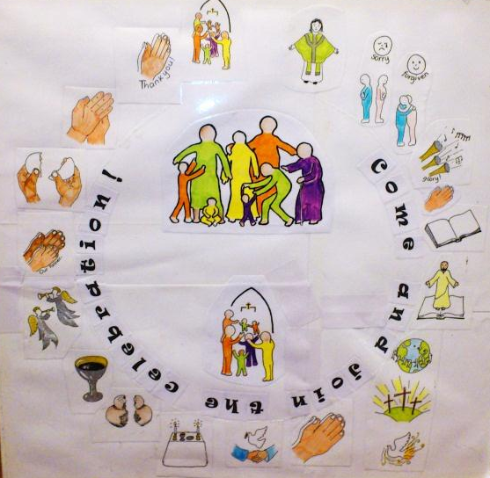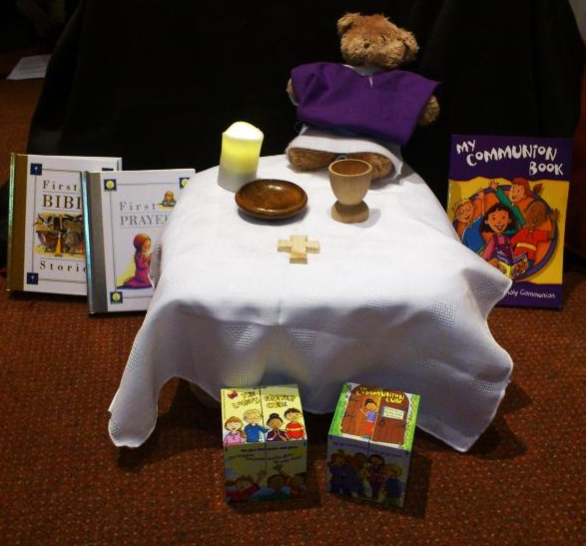
White cloth
Small cross
Battery-powered candle
Wooden egg cup
Wooden carpet protector
Teddy
Felt chasubles for teddy
Holy Communion Cube
Lord’s Prayer Cube
Children’s Bible/Prayer book
Small prayer cube
Prayer board (incercessions)
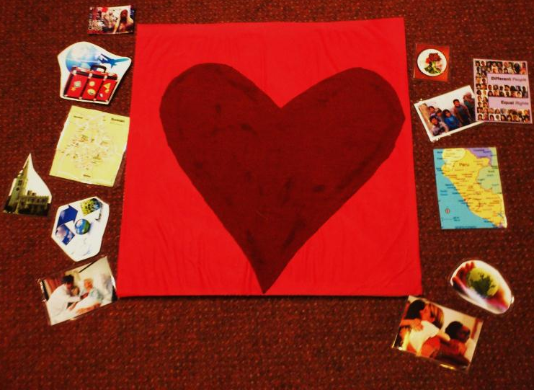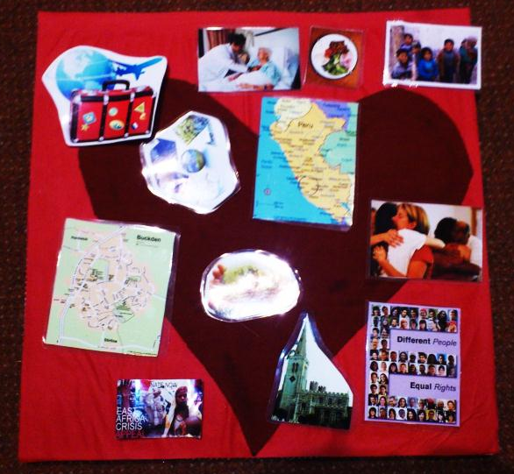
Prayer dice (intercessions) Thank you box (Eucharistic Prayer)
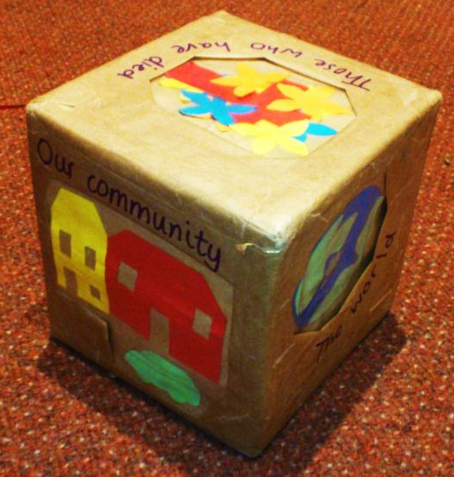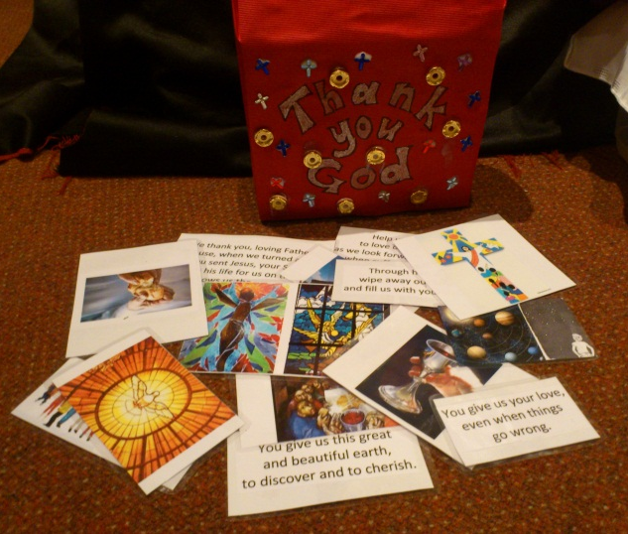
Either: images on one side illustrating the text excerpts from EP on the other side
Or: cards with the text excerpts and separate image cards, with a whole range of varied images from which the children can pick more creatively.
Enriching Children’s Experience of Eucharistic Worship in School
Not all Church Schools will feel that it is appropriate to express their Christian Ethos through Eucharistic worship, but for those that do, the Additional Eucharistic Prayers facilitate this far more effectively than the previously available provision. There are some useful pointers in the guidance notes to the Additional Eucharistic Prayers booklet. In practice, the following questions might be a useful starting point:
The School’s experience:
- What is the school’s current experience of Eucharistic worship?
- Is it a tradition that is fully embedded and a central part of the expression of the school’s Christian Ethos, or would it be a new venture?
- Are many of the children and staff actually communicants?
- How do / would communicant children from other denominations participate?
The Church’s experience:
- Does the local church have services at which children are welcome and encouraged to participate fully?
- Are the local clergy experienced in leading worship that involves significant numbers of children?
- Does the church admit children to communion while they are still at primary school?
- Do most of the church’s children attend the school in question?
Some issues / ideas worth pursuing:
- If the school holds regular Eucharistic worship, would there be scope for preparing children (with parental support and consent) for receiving communion, through an after-school or lunchtime preparation course? Might such provision ever have any relation to the RE curriculum?
- Would it be possible to pursue greater continuity between church and school worship? Using the same Eucharistic Prayer for school Eucharist and for the church’s all age Eucharistic worship, and the same musical setting can help give greater continuity, as can teaching some of the church’s favourite songs to the school for use in collective worship (whether Eucharistic or not) and using in church some of the songs known to the children through school worship.
- Having a collective worship team of children (at my school we have two children from each of the 11 classes) who are trained to plan and lead worship is good practice anyway; the same team can equally learn to plan and lead parts of Eucharistic services.
- How will you arrange the worship space? Often schools lack the space to have seating for the children in anything other than rows, which can make less formal worship difficult; If you do have room to arrange things differently, how might you do it, and are there any ways that some of the all-age ideas from the church setting might work in school? Would any of the ‘in parallel’ activities suggested work projected on a screen for everyone to see, or given to small groups of children within a school Eucharist to allow for age/experience differentiation?

