Lord of all life,
you created the universe,
where all living things
reflect your glory.

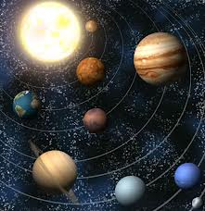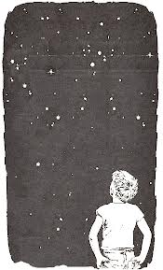

You give us this great
and beautiful earth,
to discover and to cherish.

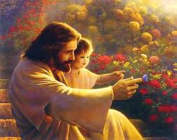

You give us your love,
even when things
go wrong.



Jesus knew hurt and pain.

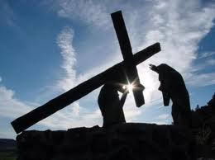

Through him you
wipe away our tears,
and fill us with your peace.

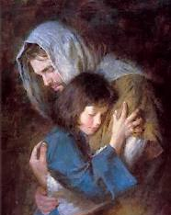

You made us all,
each wonderfully different,
to join with the angels
and sing your praise:

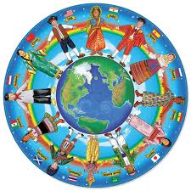

Holy, holy, holy Lord,
God of power and might,
heaven and earth are full of your glory.
Hosanna in the highest.
Blessed is he who comes
in the name of the Lord.
Hosanna in the highest.

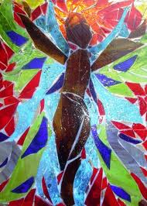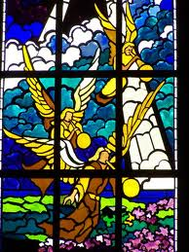

We thank you, loving Father,
because, when we turned away,
you sent Jesus, your Son.
He gave his life for us on the cross
and shows us the way to live.

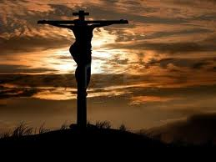

Send your Holy Spirit
that these gifts of bread and wine
may be for us Christ's body
and his blood.

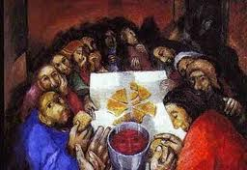

On the night before he died,
when darkness had fallen,
Jesus took bread.
He gave thanks, broke it,
and shared it with his disciples,
saying: 'This is my body,
given for you.
Do this to remember me.'

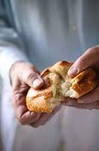
After they had eaten,
he took the cup of wine,
gave thanks, and shared it
with his disciples, saying:
'This is my blood, poured out
for you and for many,
for the forgiveness of sins.'

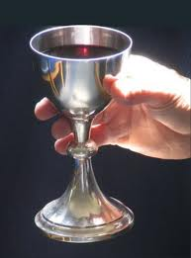

So Father,
with this bread and this cup
we celebrate his love,
his death, his risen life.
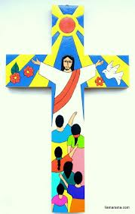

As you feed us with these gifts,
send your Holy Spirit,
and change us more and more
to be like Jesus our Saviour.

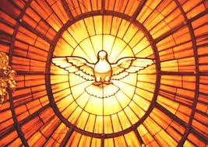

Help us, Father,
to love one another,
as we look forward to that day
when suffering is ended,
and all creation is gathered
in your loving arms.

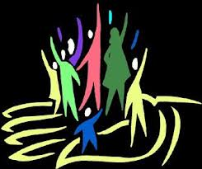

And now with all your saints
we give you glory,
through Jesus Christ,
in the strength of the Spirit,
today and for ever.

